Test link with result: <https://gateoverflow.in/quiz/results.php>

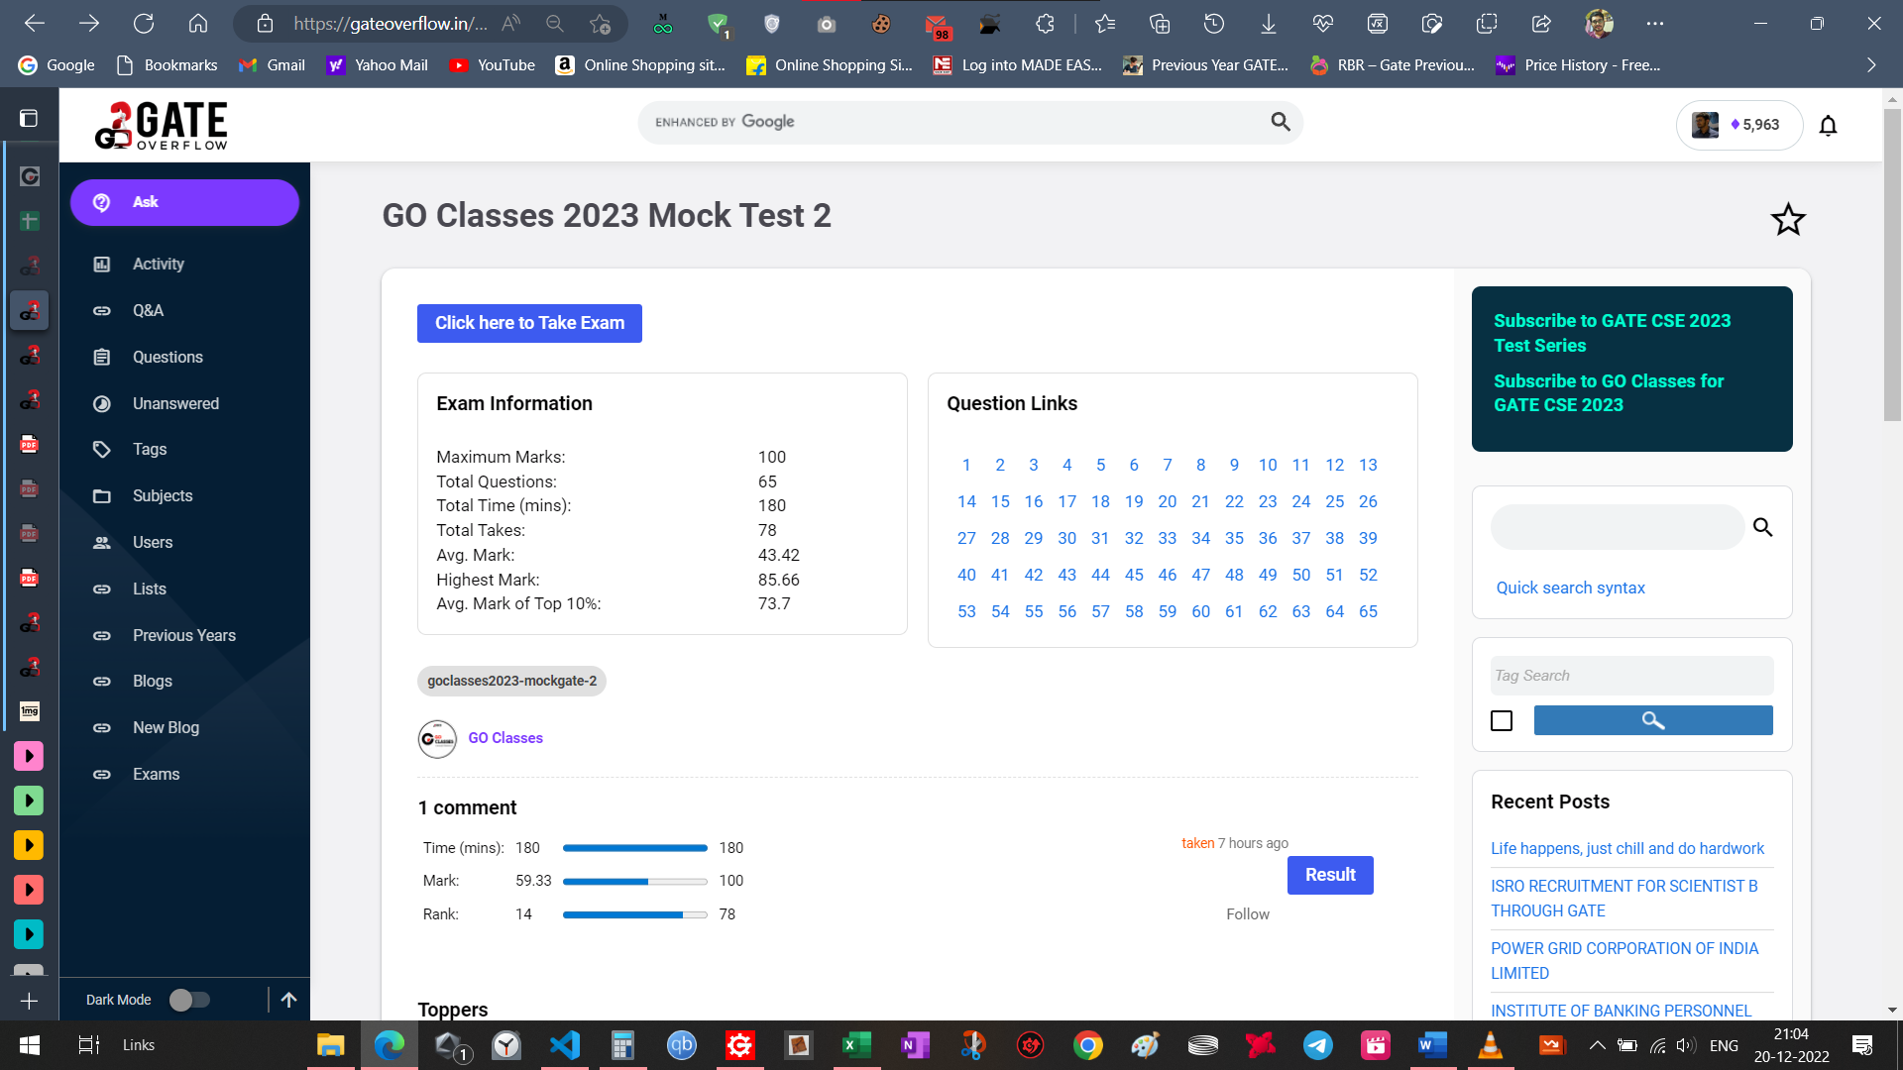

<https://gateoverflow.in/388759>

[Databases: GO Classes Test Series 2023 | Mock GATE | Test 2 | Question: 13 (gateoverflow.in)](https://gateoverflow.in/388735/go-classes-test-series-2023-mock-gate-test-2-question-13)

Countability q: <https://gateoverflow.in/388733> do after Watching all the lectures of : [Theory of Computation - Undecidability and Countability | Rice Theorem | GO Classes | GATE Overflow - YouTube](https://www.youtube.com/playlist?list=PLIPZ2_p3RNHiMGiPFIOPJG_ApL43JkILI), [Theory of Computation: GO Classes Test Series 2023 | Mock GATE | Test 2 | Question: 53 (gateoverflow.in)](https://gateoverflow.in/388656/go-classes-test-series-2023-mock-gate-test-2-question-53)

LL-1 & LR-1 do after CD rev: [Compiler Design: GO Classes Test Series 2023 | Mock GATE | Test 2 | Question: 16 (gateoverflow.in)](https://gateoverflow.in/388729/go-classes-test-series-2023-mock-gate-test-2-question-16), [Compiler Design: GO Classes Test Series 2023 | Mock GATE | Test 2 | Question: 18 (gateoverflow.in)](https://gateoverflow.in/388725/go-classes-test-series-2023-mock-gate-test-2-question-18)

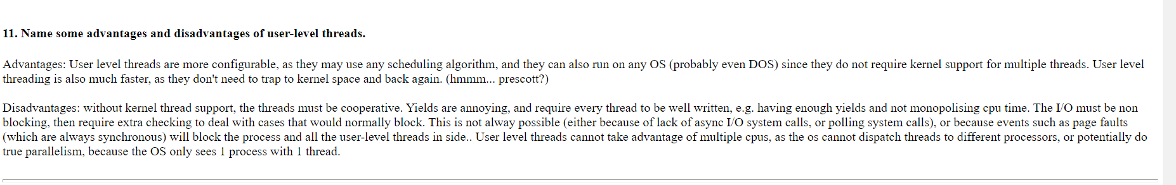

User level threads cannot take advantage of multiple cpus, as the os cannot dispatch threads to different processors, or potentially do true parallelism, because the OS only sees 1 process with 1 thread.

[Operating System: GO Classes Test Series 2023 | Mock GATE | Test 2 | Question: 22 (gateoverflow.in)](https://gateoverflow.in/388717/go-classes-test-series-2023-mock-gate-test-2-question-22)

<https://gateoverflow.in/388711/go-classes-test-series-2023-mock-gate-test-2-question-25?show=392085#c392085>

<https://gateoverflow.in/388709/go-classes-test-series-2023-mock-gate-test-2-question-26?show=392087#c392087>

Do again: [DS: GO Classes Test Series 2023 | Mock GATE | Test 2 | Question: 27 (gateoverflow.in)](https://gateoverflow.in/388707/go-classes-test-series-2023-mock-gate-test-2-question-27)

[Algorithms: GO Classes Test Series 2023 | Mock GATE | Test 2 | Question: 30 (gateoverflow.in)](https://gateoverflow.in/388701/go-classes-test-series-2023-mock-gate-test-2-question-30)

Revise Isolated IO and Memory Mapped IO and then attempt: [CO and Architecture: GO Classes Test Series 2023 | Mock GATE | Test 2 | Question: 34 (gateoverflow.in)](https://gateoverflow.in/388693/go-classes-test-series-2023-mock-gate-test-2-question-34) [The best answer is very good. Read about it again]

Good q on endianness: [Digital Logic: GO Classes Test Series 2023 | Mock GATE | Test 2 | Question: 35 (gateoverflow.in)](https://gateoverflow.in/388691/go-classes-test-series-2023-mock-gate-test-2-question-35)

Read Global/ local hit - miss rate. Then solve [CO and Architecture: GO Classes Test Series 2023 | Mock GATE | Test 2 | Question: 37 (gateoverflow.in)](https://gateoverflow.in/388687/go-classes-test-series-2023-mock-gate-test-2-question-37) [ASK ARGHARUPA]

Revise CIDR notation, netmasking, then do [Computer Networks: GO Classes Test Series 2023 | Mock GATE | Test 2 | Question: 42 (gateoverflow.in)](https://gateoverflow.in/388677/go-classes-test-series-2023-mock-gate-test-2-question-42)

Easy q on SWP: [Computer Networks: GO Classes Test Series 2023 | Mock GATE | Test 2 | Question: 43 (gateoverflow.in)](https://gateoverflow.in/388675/go-classes-test-series-2023-mock-gate-test-2-question-43)

Very good q on comb circkt: [Digital Logic: GO Classes Test Series 2023 | Mock GATE | Test 2 | Question: 45 (gateoverflow.in)](https://gateoverflow.in/388672/go-classes-test-series-2023-mock-gate-test-2-question-45)

Made a mistake, took sum to be add, but it must be XOR: [Digital Logic: GO Classes Test Series 2023 | Mock GATE | Test 2 | Question: 46 (gateoverflow.in)](https://gateoverflow.in/388670/go-classes-test-series-2023-mock-gate-test-2-question-46)

Revise Join Properties and do these qs: [Databases: GO Classes Test Series 2023 | Mock GATE | Test 2 | Question: 47 (gateoverflow.in)](https://gateoverflow.in/388668/go-classes-test-series-2023-mock-gate-test-2-question-47), [Databases: GO Classes Test Series 2023 | Mock GATE | Test 2 | Question: 48 (gateoverflow.in)](https://gateoverflow.in/388666/go-classes-test-series-2023-mock-gate-test-2-question-48)

Revise serializability, locking protocols, then do [Databases: GO Classes Test Series 2023 | Mock GATE | Test 2 | Question: 49 (gateoverflow.in)](https://gateoverflow.in/388664/go-classes-test-series-2023-mock-gate-test-2-question-49)

B+ tree pointer movement good q: [Databases: GO Classes Test Series 2023 | Mock GATE | Test 2 | Question: 50 (gateoverflow.in)](https://gateoverflow.in/388662/go-classes-test-series-2023-mock-gate-test-2-question-50)

Good q on lang checking : <https://gateoverflow.in/388660>

Solve again (hard) [Theory of Computation: GO Classes Test Series 2023 | Mock GATE | Test 2 | Question: 52 (gateoverflow.in)](https://gateoverflow.in/388658/go-classes-test-series-2023-mock-gate-test-2-question-52)

Revise L,S-attributed in CD then do [Compiler Design: GO Classes Test Series 2023 | Mock GATE | Test 2 | Question: 54 (gateoverflow.in)](https://gateoverflow.in/388654/go-classes-test-series-2023-mock-gate-test-2-question-54)

Q on cyclic grp : [Set Theory & Algebra: GO Classes Test Series 2023 | Mock GATE | Test 2 | Question: 57 (gateoverflow.in)](https://gateoverflow.in/388649/go-classes-test-series-2023-mock-gate-test-2-question-57)

Conditional prob q: [Probability: GO Classes Test Series 2023 | Mock GATE | Test 2 | Question: 58 (gateoverflow.in)](https://gateoverflow.in/388647/go-classes-test-series-2023-mock-gate-test-2-question-58)

Resource alloc graph q: [Operating System: GO Classes Test Series 2023 | Mock GATE | Test 2 | Question: 60 (gateoverflow.in)](https://gateoverflow.in/388643/go-classes-test-series-2023-mock-gate-test-2-question-60) [came in pyqs also]

Q on MST : [Algorithms: GO Classes Test Series 2023 | Mock GATE | Test 2 | Question: 61 (gateoverflow.in)](https://gateoverflow.in/388641/go-classes-test-series-2023-mock-gate-test-2-question-61), Read: <https://gateoverflow.in/388641/go-classes-test-series-2023-mock-gate-test-2-question-61?show=392118#c392118>

Q on Matching, Vertex Cover: [Graph Theory: GO Classes Test Series 2023 | Mock GATE | Test 2 | Question: 56 (gateoverflow.in)](https://gateoverflow.in/388651/go-classes-test-series-2023-mock-gate-test-2-question-56), Read: [Kőnig's theorem (graph theory) - Wikipedia](https://en.wikipedia.org/wiki/K%C5%91nig%27s_theorem_(graph_theory))

Awesome q on combinatory: [Combinatory: GO Classes Test Series 2023 | Mock GATE | Test 2 | Question: 55 (gateoverflow.in)](https://gateoverflow.in/388652/go-classes-test-series-2023-mock-gate-test-2-question-55)